**TEST 1**

**PAPER 1 READING AND WRITING** (1 hour 30 minutes)

**READING**

# PART 1

**Questions 1-5**

* Look at the text in each question.
* What does it say?
* Mark the letter next to the correct explanation - **A, B** or **C - on your answer sheet.** **Example:** 
  1. 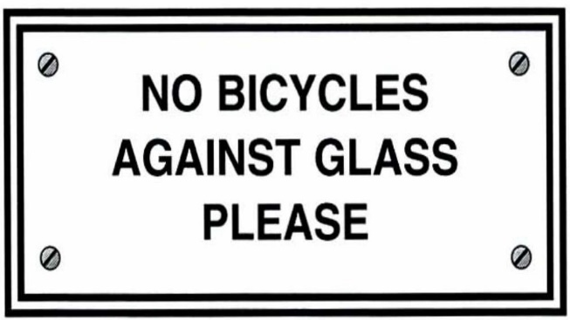**A** Do not leave your bicycle

touching the window.

**B** Do not ride your bicycle in this area.

**C**  Broken glass may damage your bicycle tyres.

**Example answer:**

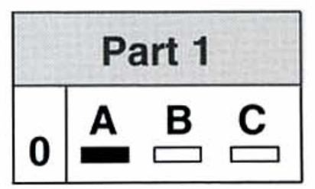

* 1. 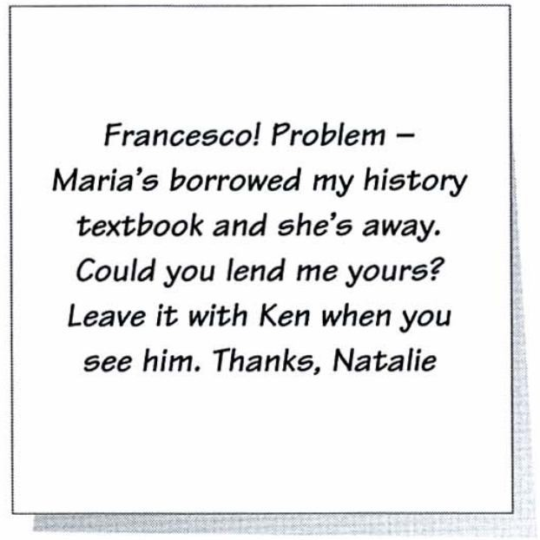**Whose textbook does Natalie want to borrow?** 
     1. Ken's
     2. Maria's
     3. Francesco's

1.** 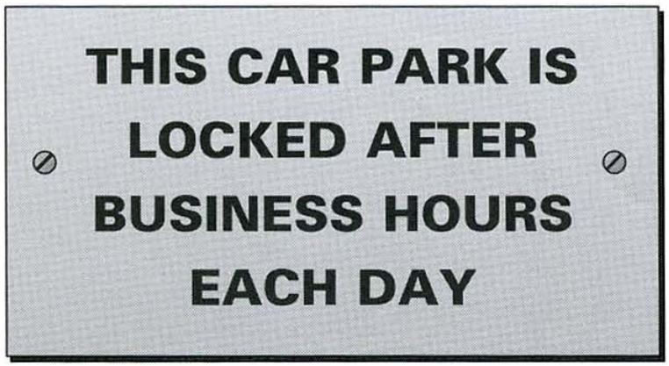.A** Users must lock the car park after leaving.
   1. People can park here while they are at work.
   2. This car park is for employees only.

1. 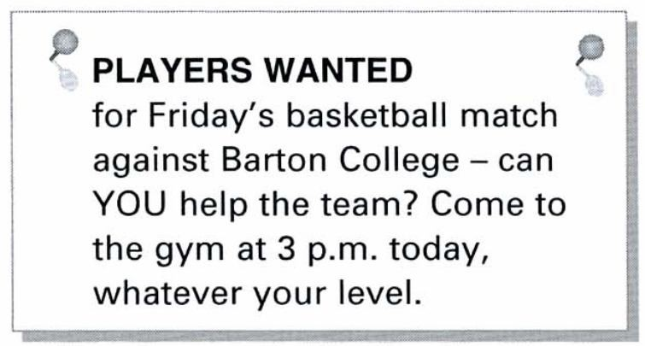**A** The basketball team only wants to see experienced players. There aren't enough team
   1. members available on Friday. The Barton College team will
   2. visit the gym later today.

1. 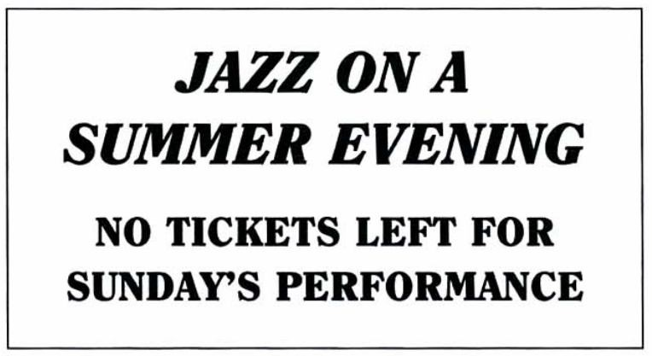**A** All Sunday evening tickets are already sold.
   1. You must book tickets for Sunday in advance.
   2. A ticket is not necessary for

Sunday evening.

1. 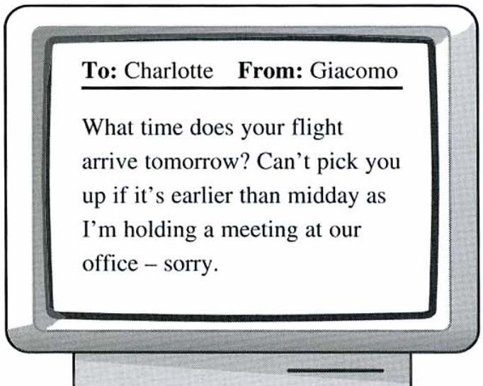**A** Giacomo will be able to see

Charlotte early tomorrow morning.

* 1. Charlotte needs to arrive in time for Giacomo's meeting tomorrow.
  2. Giacomo can collect Charlotte from the airport tomorrow afternoon.

PART 2

Question 6 10

* The people below all want to go to the cinema.
* On the opposite page there are descriptions of eight films.
* Decide which film (**letters A-H**) would be the most suitable for each person or poeple (numbers **6-10**).
* For each of these numbers mark the correct letter **on your answer sheet**.

1. Jo is studying art at university. She usually goes to the

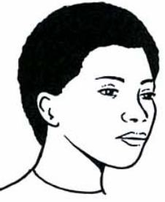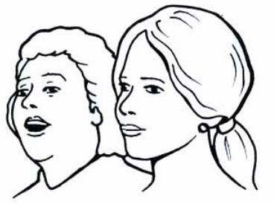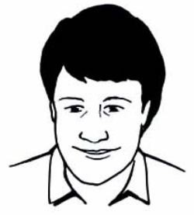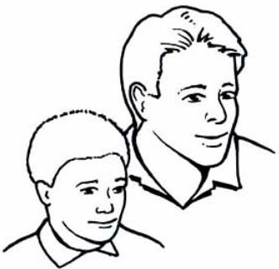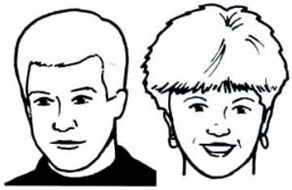

cinema on Friday evenings. She enjoys films that are based on real life and from which she can learn something.

1. Sheila has decided to take her mother to the cinema for

her birthday. They both like love stories that have happy endings.

1. Brian is a hard-working medical student. He doesn't have

very much free time, but he likes going to the cinema to relax, and enjoys a good laugh.

1. Adam wants to take his 8-year-old son Mark to the

cinema at the weekend. They want to see a film with plenty of excitement.

1. Harry and Joyce go to the cinema about twice a month.

They particularly like detective stories and do not pay much attention to which actors are in the film.

1. The Delivery

Jim Treace stars in this well-known comedy about two workmen who have to deliver a long piece of wood to a house. But unfortunately the performances are poor, and the film is too long for such a simple joke.

1. And Tomorrow We Find You A fast-moving adult story about a San Francisco policeman in danger. Based on a real-life happening, it keeps you guessing right until the last minute. Although there are no

big stars, there are some fine performances.

1. *The Ends of the Earth* **D** *Island of Fire*

A story based on a real-life journey to the You get spectacular scenery South Pole. This film contains some quite and lots of thrills in this actionwonderful wildlife photography- make sure packed story, in which a young you see it while you have the chance, or sea-captain rescues terrified you'll be sorry. villagers from a volcanic island

in the South Seas.

**E** *Out of School* **F** A Time of Silence

Here we live through a day in the life of Don't forget your handkerchief an American teenager who has problems for this story of a young not only with his parents and their college boy and girl who boring friends but also with his first manage to survive all the girlfriend who just doesn't seem to pressures of modern life. And understand him. what an unforgettable wedding

scene!

**G** *A Private Party* **H** Who Shot Malone?

A wonderfully funny comedy, which It's a surprise to see so many takes place in the 1940s. A reporter and famous names wasting their his very worried wife try to save a sheep time in this dull detective story. from the local butcher. The actors really In the end you find yourself make the most of this clever script. asking, 'Who cares?".

## PART 3 Question 11-20

* Look at the sentences below about a tour of Australia.
* Read the text on the opposite page to decide if each sentence is correct or incorrect.
* If it is correct, mark **A on your answer sheet.**
* It it is not correct, mark **B on your answer sheet**.

1. It you start your holiday on April 1st, you will return on April 19th.

1. Return flights are from Melbourne.

1. All travel between cities in Australia is by plane.

1. The cost covers accommodation and some meals.

1. You can make a reservation now for one of next year's tours

1. You have to pay the full price on the day you book.

1. You can only take this holiday in the spring or autumn.

1. If you want to go on a city sightseeing tour, you will have to pay extra.

1. The trip to Ayers Rock ends with a flight.

1. Booking is possible seven days a week.

**GLOBEWISE**

WE'LL SHOW YOU THE VERY BEST OF

## AUSTRALIA

ON A FULLY GUIDED 22-DAY TOUR

|  |  |
| --- | --- |
| **for only**  **£1985**  OUR PRICE INCLUDES   * Scheduled flights by Australia's national airline, Quantas, from London or Manchester to Perth, returning from Melbourne. * After arriving in Perth, Air   Australia flights between  Perth/Alice Springs/ Cairns/Sydney.   * Coach from Sydney to Melbourne via Canberra and Albury. * All airport transfers in Australia. * Nineteen nights' accommodation in good grade hotels with full continental breakfast. * Day trip to Ayers Rock, with a full day Barrier Reef boat trip, a visit to an Australian sheep station and city sightseeing tours in Perth, Alice Springs, Sydney, Canberra and Melbourne. * All state and local taxes. * Hotel baggage handling. * Experienced Globewise   Tour Manager at all stages of the trip. | You can pay just £90 now to be sure of your place on this successful and popular touring holiday next year.  There are departures right through the year. We make sure you see the very best of everything which  Australia has to offer. |
| **PERTH**  included.  **ALICE SPRINGS**  A  'School of the Air'.  **AYERS ROCK**  town of  **GREAT BARRIER REEF**  fish and other sea creatures.  **SYDNEY**  beauty of Australia's biggest c |

Wonderful long, golden beaches, superb restaurants serving fabylous food in delightful surroundings, lush green parks and the beautiful Swan River. City sightseeing tour

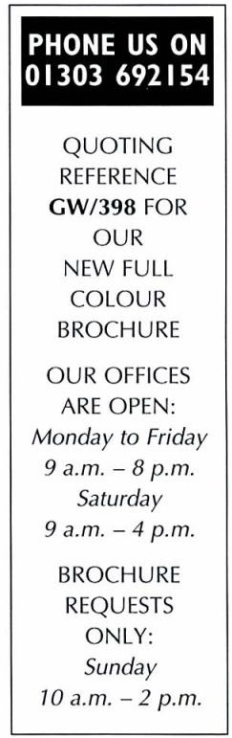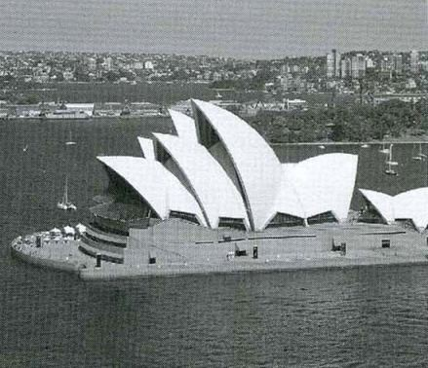

ity

-

Fly over the outback to famous

Alice Springs in the heart of boriginal country. Full sightseeing tour. See Flying Doctor base and

Drive to Yulara National Park. Visit the mysterious Olgas and Ayers Rock with its caves and Aboriginal rock paintings. Fly on to the lively seaside Cairns and relax in the sun.

We've included a full day's boat trip on the famous reef with the chance to see amazing, brightly coloured

You'll love the excitement and

we've included a sightseeing tour

and a visit to the famous Opera House. You can also

book a day trip to the Blue Mountains.

**MEBLOURNE**

We've included a city sightseeing tour-or you can visit the Penguin Parade.

**We promise that by the end of the trip you'll be wanting to return!**

### PART 4 Questions 21-25

* Read the text and questions below.
* For each question, mark the letter next to the correct answer - **A, B, C** or **D - on your answer sheet**.

A month ago I had no idea that on a Saturday afternoon in November I'd be hanging 30 metres above the ground and enjoying it. Now I looked down at the river far below me, and realised why people love rock-climbing.

My friend Matt and I had arrived at the Activity Centre on Friday evening. The accommodation wasn't wonderful, but we had everything we needed (beds, blankets, food), and we were pleased to be out of the city and in the fresh air. On Saturday morning we met the other ten members of our group. Cameron had come along with two friends, Kevin and Simon, while sisters Carole and Lynn had come with Amanda. We had come from various places and none of us knew the area.

We knew we were going to spend the weekend outdoors, but none of us was sure exactly how. Half of us spent the morning caving while the others went rock-climbing and then we changed at lunchtime. Matt and I went to the caves first. Climbing out was harder than going in, but after a good deal of pushing, we were out at last - covered in mud but pleased and excited by what we'd done.

1. What is the writer trying to do in the text?
   1. advertise the Activity Centre
   2. describe some people she met
   3. explain how to do certain outdoor sports
   4. say how she spent some free time
2. What can the reader learn from the text?
   1. when to depend on other people at the Centre
   2. how to apply for a place at the Centre
   3. what sort of activities you can experience at the Centre
   4. which time of year is best to attend the Centre

1. How do you think the writer might describe her weekend?
   1. interesting
   2. relaxing
   3. frightening
   4. unpleasant
2. What do we learn about the group?
   1. Some of them had been there before
   2. They had already chosen their preferred activities.
   3. Some of them already knew each other
   4. They came from the same city
3. Which of the following advertisements describes the Activity Centre?

|  |  |  |
| --- | --- | --- |
| **ACTIVITY CENTRE**  Set in beautiful countryside.  Accommodation and meals provided. Make up your own timetable-choose from a variety of activities (horseriding, fishing, hill-walking, sailing, mountain-biking). | **B** | **ACTIVITY CENTRE**  Set in beautiful countryside.  Accommodation provided. Work with a group-we show you a range of outdoor activities that you didn't realise you could do! |

**A**

|  |  |  |
| --- | --- | --- |
| **ACTIVITY CENTRE**  Set in beautiful countryside. Enjoy the luxury of our accommodation - each room has its own bathroom. Work with a group, or have individual teaching. | **D** | **ACTIVITY CENTRE**  Set in beautiful countryside. You can spend the day doing outdoor activities and we will find your accommodation with a local family. |

**C**

### PART 5 Questions 26-35

* Read the text below and choose the correct word for each space.
* For each question, mark the letter next to the correct word - **A, B, C** or **D - on your answer sheet.**

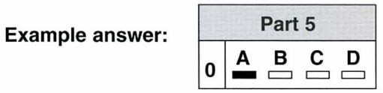

**THE FIRST WOMAN SCIENTIST**

Hypatia was **(0)**....... in Alexandria, in Egypt, in 370 A. D. For many centuries she was **(26)**............... only woman scientist to have a place in history books.

Hypatia's father was director of Alexandria University, and he **(27)**.............. sure his daughter had the best education available. This was unusual, as most women then had few **(28)** …………. to study.

After studying in Athens and Rome, Hypatia returned to Alexandria **(29)**

…………. she began teaching mathematics. She soon became famous

**(30)**................ her knowledge of new ideas.

We have no copies of her books, **(31)**................. we know that she wrote several important mathematical works. Hypatia was also interested in technology and

**(32)**.................. several scientific tools to help with her work.

At the **(33)**................ many rulers were afraid of science, and **(34)**............... connected with it was in danger. One day in March 415, Hypatia **(35)**..........

attacked in the street and killed.

**0** **A** born **B** begun **C** developed **D** grown

1. **A** one **B** the **C** a **D** an
2. **A** could **B** made **C** said **D** put
3. **A** classes **B** customs **C** opportunities **D** teachers
4. **A** where **B** how **C** there **D** which
5. **A** from **B** by **C** for **D** in
6. **A** because **B** but **C** or **D** as
7. **A** did **B** experimented **C** invented **D** learnt
8. **A** day **B** period **C** year **D** time
9. **A** anyone **B** nobody **C** all **D** something
10. **A** was **B** had **C** has **D** is

**WRITING**

### PART 1 Question 1-5

* Here are some questions about a family.
* For each question complete the second sentence so that it means the same as the first, **using no more than three words**.
* **Write only the missing words on your answer sheet**.

**Example**: My brother is older than me.

**I am** *younger than* **my brother.**

1. My parents prefer jazz to classical music.

**My parents think jazz**  **than classical music**.

1. My parents can only go swimming at the weekend.

**On weekdays,** **my parents aren't** **go swimming.**

1. If I finish my homework, I can go out at the weekend.
   1. **can't go out at the weekedn**  **finish my homework.**
2. My sister watches more TV than me.
   1. **don't watch TV** **my sister does.**
3. My parents suggested going out for a meal.

**My parents said, ‘Why**  **we go out for a meal?’**

**PART 2**

# Question 6

You have invited your English friend Jo to saty with you next month, but you now need to delay this visit.

### Write a card to send to Jo. In your card, you should

* apologise to Jo
* explain why the visit has to be delayed
* suggest when it would be convenient for Jo to come.

**Write 35-45 words on your answer sheet.**

**PART 3**

Answer **one** of the following questions (**7** or **8**)

### Question 7

* Your English teacher has asked you to write a story.
* Your story must begin with this sentence:

**Carla looked at the car in surprise.**

* Write your **story** in about 100 words **on your answer sheet.**

### Question 8

* This is part of a letter you receive from an English friend.

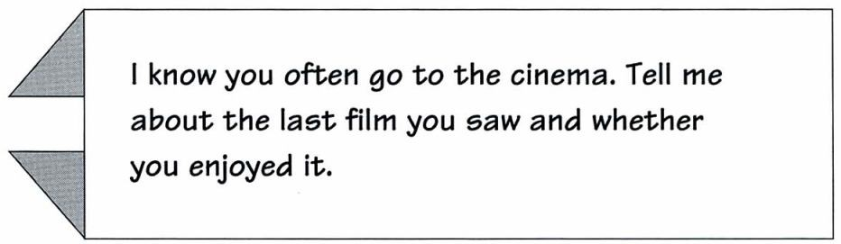

* Now write a letter to your friend.
* Write your **letter** in about 100 words **on your answer sheet.**

**PAPER 2 LISTENING** about 35 minutes

(including 6 minutes transfer time)

### PART 1 Questions 1-7

* There are seven questions in this part.
* For each question there are three pictures and a short recording.
* Choose the correct picture and put a tick (✓) in the box below it.

**Example**: What's the time?

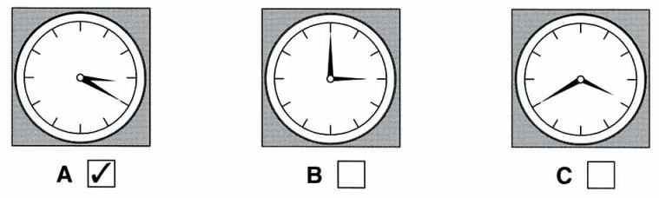

1. Where will the girls meet?

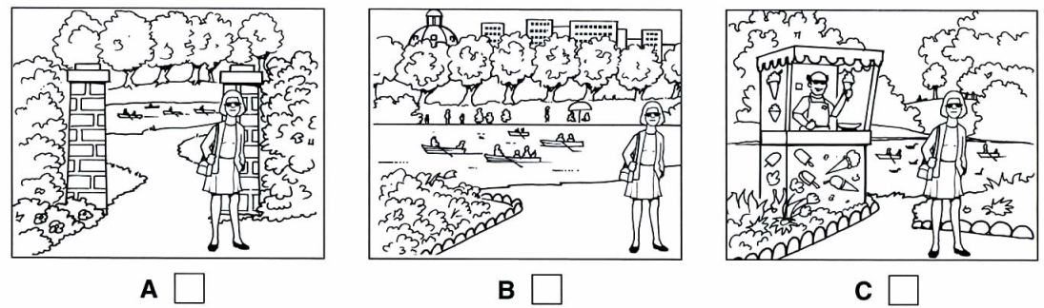

1. Which chair does the man want?

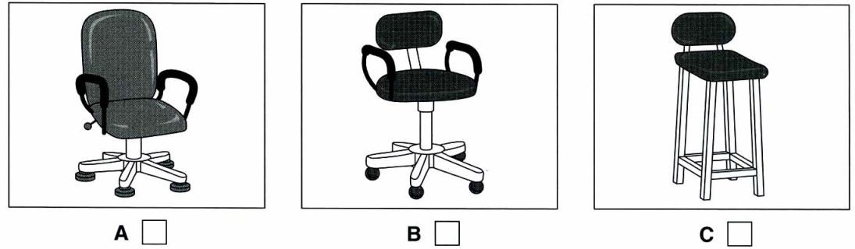

1. Which picture shows what the girls need?

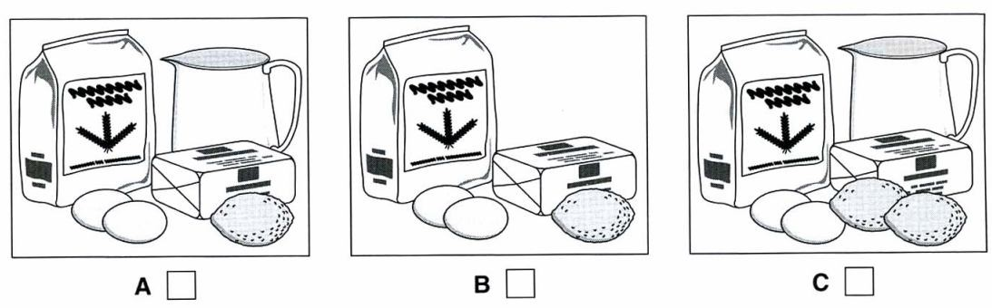

1. Which picture shows what happened?

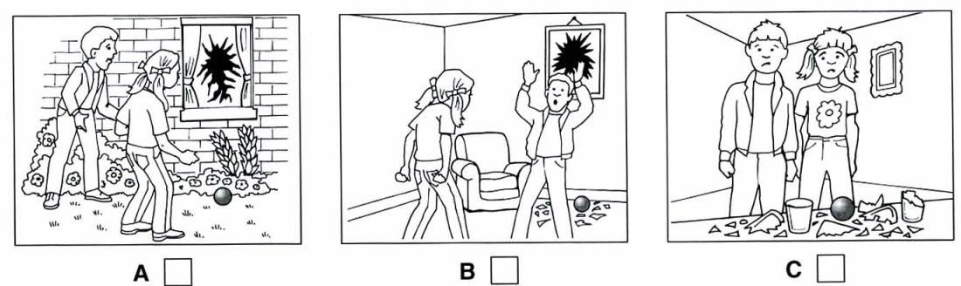

1. What is Sarah's mother doing?

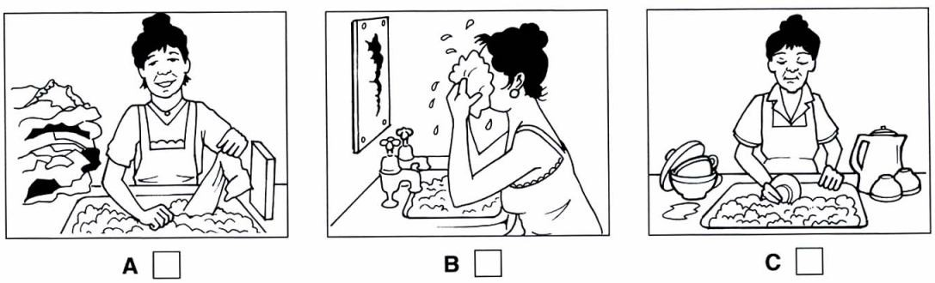

1. What luggage is the man taking on holiday?

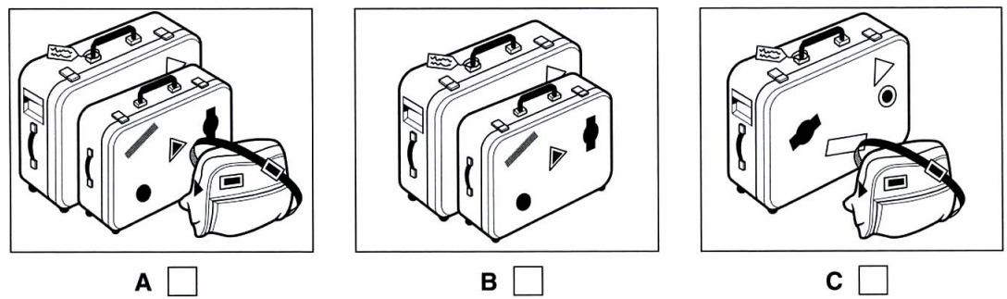

1. Which photograph does the man like?

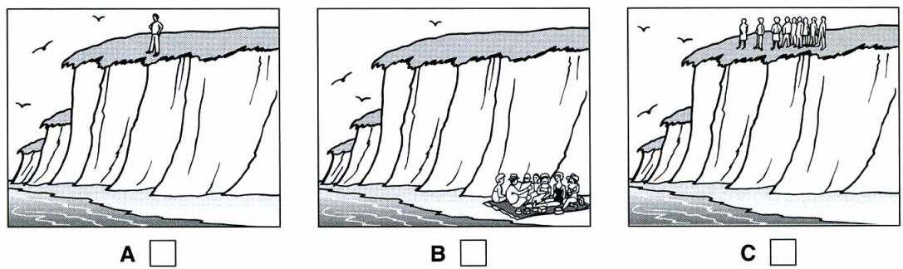

### PART 2 Questions 8-13

* You will hear part of a radio programme about classical music.
* For each question, put a tick (✓) in the correct box.

1. This week's prize is **A** □a music cassette.
   1. □two concert tickets.
   2. □a classical CD.

1. The person who wrote the music **A** □Italy. lived in **B** □Spain.
   1. □France.

1. What else shares the title of this **A** □a garden music? **B** □a play
   1. □a park

1. What did people do when they first **A** □Some left before the end. heard the music? **B** □Only a few clapped.
   1. □Some asked for their money back.

1. This piece of music has been **A** □ played in the cinema.

**B** □used in advertising. **C** □used for a TV play.

1. If you know the competition **A**  □ 0108 937 224. answer you should ring **B**  □ 0018 739 242. **C**  □0018 937 224.

### PART 3 Questions 14-19

* You will hear a radio programme in which young people from different parts of the country are interviewed.
* For each question, fill in the missing information in the numbered space.

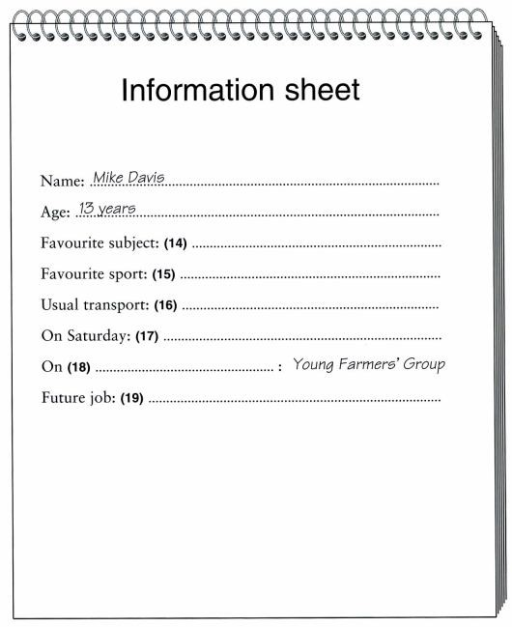

### PART 4 Questions 20-25

* Look at the six sentences for this part.
* You will hear a conversation between a boy, Jim, and his mother.
* Decide if each sentence is correct or incorrect.
* If it is correct, put a tick (✓) in the box under **A** for **YES**. If it is not correct, put a tick (✓) in the box under **B** for **NO**.

### A B

**YES NO**

1. Jim's bicycle needs to be mended □ □
2. He's keen to start saving money. □ □
3. His mother thinks a mountain bike is suitable for their area. □ □
4. She encourages Jim to manage his money better. □ □
5. His mother offers to lend him some money. □ □
6. Jim is disappointed by his mother's suggestion. □ □

### About the Speaking test

The Speaking test lasts about 10 to 12 minutes. You take the test with another candidate. There are two examiners in the room. One examiner talks to you and the other examiner listens to you. Both the examiners give you marks. *Part 1*

The examiners introduce themselves and then one examiner asks you and your partner to say your names and spell them. This examiner then asks you questions about yourself, your daily life, interests, etc. *Part 2*

The examiner asks you to talk about something together and gives you a drawing to help you. *Part 3*

You each have a chance to talk by yourselves. The examiner gives you a colour photograph to look at and asks you to talk about it. When you have finished talking, the examiner gives your partner a different photograph to look at and to talk about. *Part 4*

The examiner asks you and your partner to say more about the subject of the photographs in Part 3. You may be asked to give your opinion or to talk about something that has happened to you.